ODT Summative 2
Idea Brief :
The doll will move across the stage to specific predefined points points beginning from a home position in an order as the user wants as inputted by the user in the MIT app as music plays in the background. When the doll reaches the edge of the platform it is on , it will move away from the edge. The top of the doll will also spin at certain intervals to create a experience of it dancing

Basic Idea Sketch :

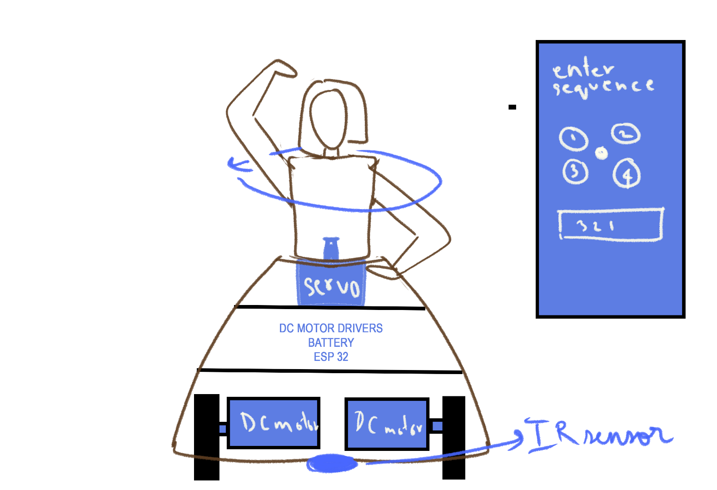
STEPPER MOTOR DRIVER

